CURRENT POSITION:
The survey currently sits on SurveyMonkey. I am happy with the survey as is and also happy with surveymonkey as its reliability and security are robust.
The survey consists of 12 questions and 4 statements on each – you have to rank order from most like me to least like me. (In essence 12 questions and 48 statements).
Each statement belongs to one of the 4 archetypes.
I email the person a link or provide a QR Code – critical in the automation process and perhaps even prior to the final build, I need the following a QR Code that I can put in the publication that uses a REDIRECT from my epitome-leadership.com website to SURVEYMONKEY.
Currently it is just a QR code or link from Surveymonkey.
Person completes the assessment – I have to check the spreadsheet and/or surveymonkey as I am not automatically notified.
Laura built an excel spreadsheet and everything is imported from SurveyMonkey. We wanted to capture the information to build validity/gravitas etc around the tool for when I am presenting to a potential client or just giving a presentation.
She created some equation to invert the scores as I required a radar diagram with the “most like me” responses on the outside and and the “least like me” responses on the inside.
This was done to create a radar / spider diagram that I wanted (see below) You can see the numbers on the diagram which can be confusing as you the person has rated something from most like me (1) to least like me (4)… yet the opposite is true on the diagram – I would be keen to get rid of the numbers or have them going from 1 – 4 in the opposite direction. The results spit out a radar diagram on the 12 dimensions.
She also had something that added up Most Like me through to least like me on each archetype so I am able to tell the person you currently lead using X archetype.
The automation needs to capture if the second most selected archetype is within two points of the leading archetype, I assign that as they lead with BOTH archetypes as a constellation. THIS IS VERY IMPORTANT TO CAPTURE (I currently review with my eye).
If the second archetype is greater than 2 points from the highest, I would not report on it as a leading archetype.

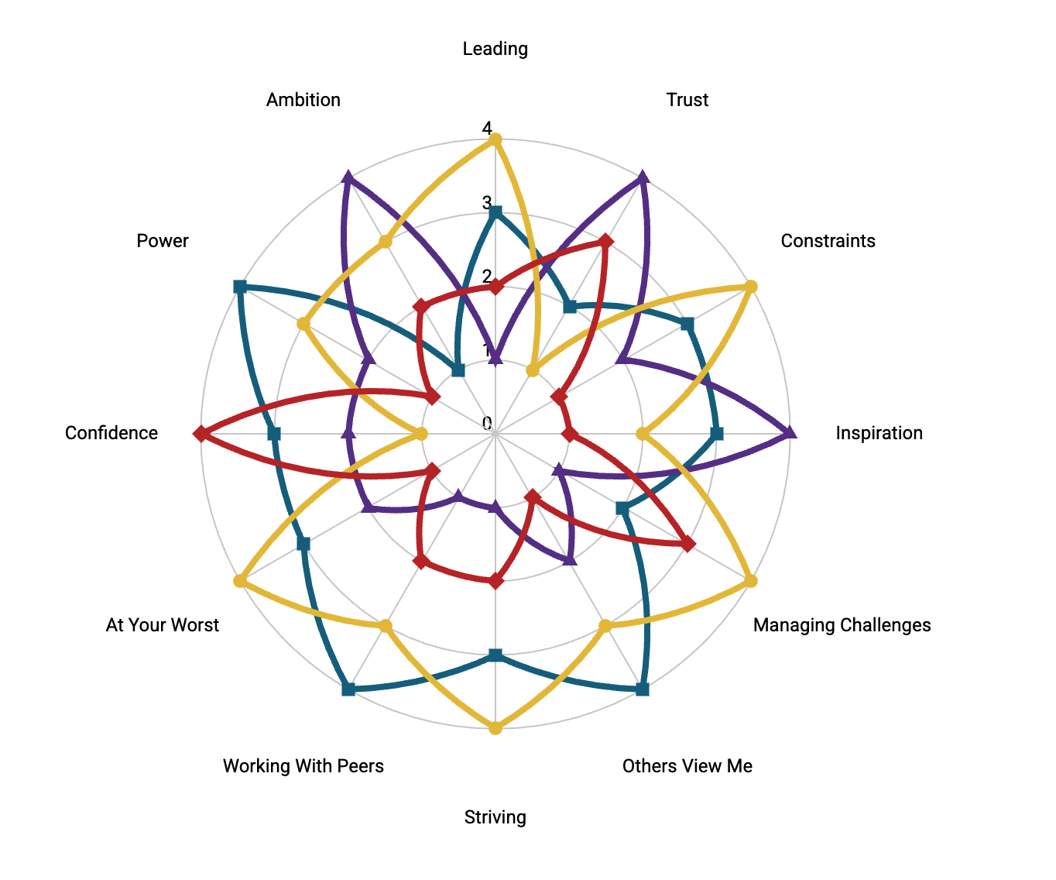
I manually take the information from the excel spreadsheet:
- Name
- Leading archetype(s)
- Radar diagram
- Their email
Make changes on the pdf using Adobe Live
Email the person with their personalised report.

My ask and notes–
- Yellow highlight is urgent as I want the redirect to happen before publication which is slated for mid August
- Fully automated
- information captured and retained
- initially I would want oversight before the report was sent out but after we are comfortable it is working, just send it out with no oversight.
- I am not wedded to any particular technology.
- Wilko suggested Google Firestore with the Blaze plan for a database holder (lol not his words)
- And also suggested CloudFlare for redirection.
- Wilko could help with the redirect and definitely with security stuff….

